WiFi broadcasting:

Apparently, direct WiFi broadcasting is not possible. We don’t have access to hardware and operate WiFi module to broadcast certain info.

Ideal circumstance:

Just like normal wireless sensing devices, we can choose to broadcast information through the channel.

Possible other solutions:

WiFi Direct

Android sdk provides a p2p API for developers to establish p2p networks quickly and conveniently.

By initializing *WiFiP2pManager*, an Android device will enable WiFi Direct and start scanning other p2p devices also enabling p2p service.

However, before calling *discoverPeers* method, a device will not broadcast its own p2p info as well as detecting other existing p2p node.

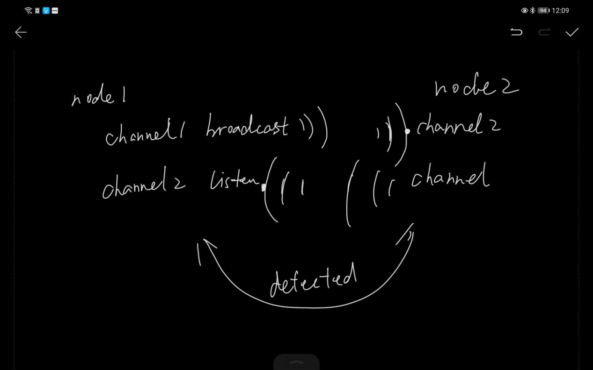

There are two or three different channel for WiFi p2p sensing and broadcasting.

One of the channel keeps broadcasting signals for other nodes to sense.

One other channel keeps sensing broadcasting info from other nodes.

Problems for WiFi Direct:

1. Don’t have access to rssi value of sensed devices.

WiFi and Hotspot

Device use hotspot as the broadcasting state. From the hotspot name of mac addr we can identify devices, etc.

During the process, devices request and update WiFi scanning list. This can be seen as listening broadcasting signals.

Drawbacks:

1. In Android 9, app is allowed to scan WiFi-list 4 times in 2 minutes. In Android 10, WiFi scanning throttling can be switched off in developers option. Android earlier than 9 doesn’t has this limitation.
2. Broadcasting info is still not very flexible. Likely to expose some device unique information.
3. Devices will constantly switch hotspot name since we don’t want devices could impersonate others.

Advantages:

1. We can get RSSI from WiFi scanning information
2. WiFi scan is not as time consuming as WiFi Direct.